

Football Performance Analysis
A PROJECT REPORT
Submitted by
Ashutosh Dash (26MCD10089)
in partial fulfilment for the award of the degree of
Masters of Computer Applications
IN
Data science

2026-28

Chandigarh University
2026 - 28
BONAFIDE CERTIFICATE
Certified that this project report titled “Football Performance Analysis using Python” is the bonafide work of Ashutosh Dash (UID: 26MCD10089) who carried out the project work under my/our supervision in partial fulfillment of the requirements for the award of the degree of Master of Computer Applications at Chandigarh University.

Name: Ashutosh Dash | Name: Er. Prabhjot Kaur
UID : 26MCD10089 | Designation: Assistant Professor
Department: MCD - 2 | SUBJECT CODE : E17274
SIGNATURE | SIGNATURE
Submitted for the project viva-voce examination held on

ACKNOWLEDGEMENT
The successful completion of this project would not have been possible without the guidance, support, and encouragement of several individuals and organizations. It is a matter of great pleasure and privilege for me to express my sincere gratitude to all those who contributed directly or indirectly towards the completion of this project titled “Football Performance Analysis using Python.” First and foremost, I would like to express my heartfelt gratitude to Chandigarh University for providing me with the opportunity to undertake this project as a part of my academic curriculum. The university has provided an excellent learning environment, modern facilities, and valuable resources that helped me gain practical knowledge and technical skills throughout the course of this project.
I would like to convey my deepest appreciation to my project supervisor for providing constant guidance, constructive suggestions, and continuous motivation during every stage of the project. Their valuable insights, technical expertise, and willingness to share knowledge played a crucial role in the successful completion of this work.
I extend my sincere appreciation to the Head of Department, MCA, and to the faculty members and staff of the University Institute of Computing for their support and cooperation throughout the project duration. Their academic guidance and timely feedback helped me understand the practical application of data analysis using Python. Developing my first data analysis project presented several challenges, and I am grateful for the support I received along the way.
Special thanks are extended to my friends and classmates, and to my parents, who continuously encouraged me and shared valuable suggestions throughout the development process. Their feedback and moral support helped me improve various aspects of the project and remain motivated during challenging phases of implementation.
Ashutosh Dash
UID: 26MCD10089
INDEX
S. No. | Contents | Section
1 | Introduction | 1
2 | Objectives and Problem Statement | 2
3 | Tools and Technologies Used | 3
4 | Football Performance System Design and Workflow  Football Performance Dashboard  Players Page  Teams Page  Best Player Ranking  Application Workflow and Flowchart | 4  4.1  4.2  4.3  4.4  4.5
5 | Implementation, Modules and Results  Main Application Module  Data Loading and Inspection  Feature Derivation  Analysis Module  Visualisation Module  Dataset Used and Console Output  Interpretation of Results  Dashboard, Best Player Chart and Heat Map | 5  5.1  5.2  5.3  5.4  5.5  5.6  5.7  5.8
6 | Advantages and Limitations | 6
7 | Future Scope | 7
8 | Conclusion | 8
9 | References | 9
10 | GitHub Repository | 10

1. INTRODUCTION

1.1 Overview
Football generates a large amount of numerical data in every match: goals, assists, shots, passes and minutes played. Coaches, analysts and clubs use this data to judge who is performing well, which team is more efficient and where improvement is needed. Manually calculating ratios and rankings for every player is slow and error-prone, and the results are difficult to present clearly.
Football Performance Analysis using Python is a data-analysis project that addresses this problem with a single, repeatable Python script. It reads the statistics of sixteen players from four teams (Red Lions, Blue Hawks, Green Tigers and Yellow Wolves) from a CSV file, cleans and extends the data with calculated columns, analyses it using NumPy and Pandas, and presents the findings through charts created with Matplotlib and Seaborn.
The project is a complete, small-scale example of the data-analytics workflow: collect, prepare, analyse, visualise and communicate. It runs offline on an ordinary laptop and needs only standard open-source Python libraries.

1.2 Background and Motivation
Sports analytics is a contemporary and fast-growing field. Professional clubs employ data analysts who study event data, tracking data and wearable-sensor data to improve tactics, reduce injuries and scout talent. Open-source tools such as Python now allow students to carry out similar analysis without expensive software. Several issues motivated this project:
- Data-driven decision making: Clubs increasingly prefer evidence from data over personal opinion when selecting players.
- Fair comparison: Raw goal counts can mislead because players play different numbers of matches; normalised measures such as goals per match are fairer.
- Visual communication: A chart communicates an insight faster than a table of numbers, making visualisation a core skill.
The motivation behind this project is therefore to build a transparent, easily explained set of measures and show how a short script can turn raw match statistics into clear, decision-ready insights.

1.3 Project Scope
The scope of the project is to analyse the performance of sixteen players from four teams and answer practical questions: Who are the top scorers? Who is the best all-round attacking contributor? Which team is the most productive? Which playing position passes most accurately? Are shots and goals related? The scope includes the following functionality:
- Loading the player dataset from a CSV file and inspecting its shape and missing values.
- Deriving Goals per Match, Shot Accuracy, Goal Contributions and Best Player Score.
- Identifying the top scorers and ranking players by Best Player Score.
- Aggregating team totals of goals, assists and shots.
- Comparing average pass accuracy by playing position.
- Measuring the correlation between shots and goals.
- Producing a four-panel dashboard, a best-player chart and a correlation heat map saved as PNG images.
The project is limited to descriptive analysis of one season of statistics; it does not predict future results. It provides a foundation for future improvements such as richer metrics, larger datasets and predictive modelling.
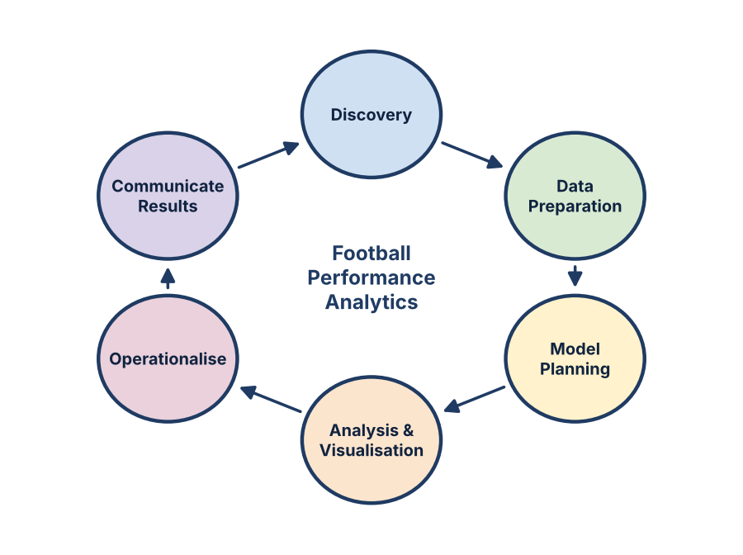
Figure 1: Data analytics lifecycle followed in the project.

1.4 Project Timeline
The project was planned in six phases, shown in Table 1.1 and Figure 2, starting from problem definition and ending with the finalisation and submission of the report. The first phases required the most thinking time because the choice of derived measures decides the quality of every later result. The coding itself, being a single script of about eighty lines, took only a few sittings; the remaining time went into checking results and presenting them clearly.
Table 1.1: Estimated Timeline of the Project
Phase | Activity | Duration
Phase 1 | Problem definition and planning | 01 Sep – 10 Sep 2026
Phase 2 | Data collection and preparation of players.csv | 11 Sep – 20 Sep 2026
Phase 3 | Data cleaning and new column creation | 21 Sep – 30 Sep 2026
Phase 4 | Analysis and visualisation | 01 Oct – 05 Oct 2026
Phase 5 | Report writing and revision | 06 Oct – 09 Oct 2026
Phase 6 | Finalisation and submission | 10 Oct 2026
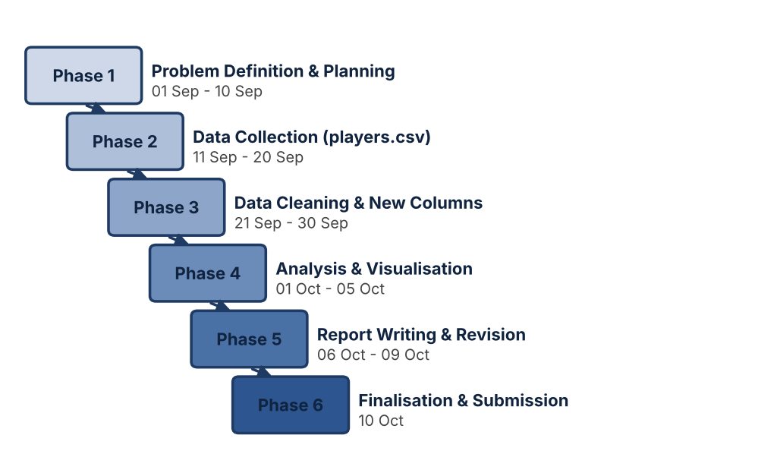
Figure 2: Timeline of the project.

2. OBJECTIVES AND PROBLEM STATEMENT

2.1 Problem Statement
Given a table of player statistics for several teams, the problem is to (i) check the quality of the data, (ii) derive fair comparison measures, (iii) identify top performers, strongest teams and position-wise differences, (iv) test whether shooting volume is related to goals scored, and (v) present these findings in clear visual form using Python.
Spreadsheets require formulas to be rewritten for every dataset and are difficult to repeat automatically, while BI tools and commercial analytics platforms need licences or special training and give less control over custom calculations. A free, reproducible, script-based approach is therefore needed, and Python with Pandas, NumPy, Matplotlib and Seaborn was chosen for this purpose.

2.2 Objectives
The primary objectives of the project are:
- To write a clean, well-commented Python program that reads and inspects the player dataset.
- To check the dataset for its shape and missing values.
- To create Goals_Per_Match, Shot_Accuracy, Goal_Contributions and Best_Player_Score using NumPy and Pandas.
- To identify the top scorers and the best overall player.
- To aggregate team totals of goals, assists and shots.
- To compare average pass accuracy by playing position.
- To measure the correlation between shots and goals.
- To produce a dashboard, a ranking chart and a correlation heat map and save them as PNG files.
- To document the project in the MCA project-file format with figures and diagrams.

2.3 Functional Requirements
Functional requirements describe the operations the program must support.
Requirement ID | Functional Requirement
FR-01 | The program shall load player statistics from a CSV file into a DataFrame.
FR-02 | The program shall display the first rows, the shape and the missing-value count of the data.
FR-03 | The program shall derive Goals_Per_Match, Shot_Accuracy, Goal_Contributions and Best_Player_Score.
FR-04 | The program shall list the top three scorers and the top five players by Best_Player_Score.
FR-05 | The program shall compute team totals and average pass accuracy by position.
FR-06 | The program shall compute the correlation between shots and goals.
FR-07 | The program shall draw the dashboard, best-player chart and heat map.
FR-08 | The program shall save every chart as a PNG image.

2.4 Non-Functional Requirements
Non-functional requirements define the quality characteristics of the program.
Requirement | Description
Usability | Results should be printed in readable form and charts should be easy to interpret.
Performance | The script should run in a few seconds on a normal laptop.
Reliability | The script should handle zero-shot players without division-by-zero errors.
Maintainability | The code should be short, commented and divided into clear numbered steps.
Portability | The script should run on any system with Python 3 and the required libraries.
Reproducibility | The script should locate its own folder so that files are found wherever it is started from.
Data Integrity | The raw dataset should not be modified; new values are stored as additional columns.

2.5 Stakeholders and Need
The stakeholders of such a system are team coaches, who need an objective view of player contribution; club managers and selectors, who decide whom to retain or sign; sports journalists and fans, who want clear statistics; and students and researchers who want a reproducible example of sports analytics. The objectives are therefore specific and measurable: compute per-match efficiency measures, rank players with a single transparent score, compare teams and positions, and present all results visually so that a non-technical reader can understand them quickly.

3. TOOLS AND TECHNOLOGY USED

3.1 Python
Python 3 is the core programming language used to write the whole program. It provides a readable programming environment and extensive support for file handling, numerical computation, data analysis and visualisation.

3.2 NumPy
NumPy (Numerical Python) provides fast array calculations. In this project np.round is used to round derived values, np.where handles the zero-shot condition in Shot_Accuracy, and np.corrcoef computes the shots–goals correlation.

3.3 Pandas
Pandas provides the DataFrame structure used to hold the player data. The functions read_csv, head, isnull, nlargest, sort_values, idxmax, groupby and corr are used for loading, inspecting, ranking, aggregating and correlating the data.

3.4 Matplotlib
Matplotlib is used to create figures and subplots and to save the charts as PNG images using savefig.

3.5 Seaborn
Seaborn builds on Matplotlib and provides statistical charts such as barplot, scatterplot, boxplot and heatmap with very little code. It was chosen for most charts because it produces readable graphics with attractive default styling.

3.6 CSV File Format
The player statistics are stored in players.csv, a plain-text Comma Separated Values file with eleven columns and sixteen rows. It can be opened in any editor or spreadsheet and is read directly by Pandas.

3.7 Development Tools
Visual Studio Code is the code editor and Git is used for version control.
Table 3.1: Technology Stack
Technology | Purpose
Python 3 | Core programming language used to write the whole program
NumPy | Fast array calculations: np.round, np.where, np.corrcoef
Pandas | DataFrame handling: read_csv, nlargest, sort_values, groupby, corr
Matplotlib | Figure and subplot creation, saving charts as PNG (savefig)
Seaborn | Statistical charts: barplot, scatterplot, boxplot, heatmap
VS Code / Git | Code editor for development and version control

4. FOOTBALL PERFORMANCE SYSTEM DESIGN AND WORKFLOW

4.1 Football Performance Dashboard
The Football Performance Analysis web application opens on the dashboard, which reads the data live from football.db. It shows the season overview (total players, goals, shots and average pass accuracy) and highlights the best player of the season.
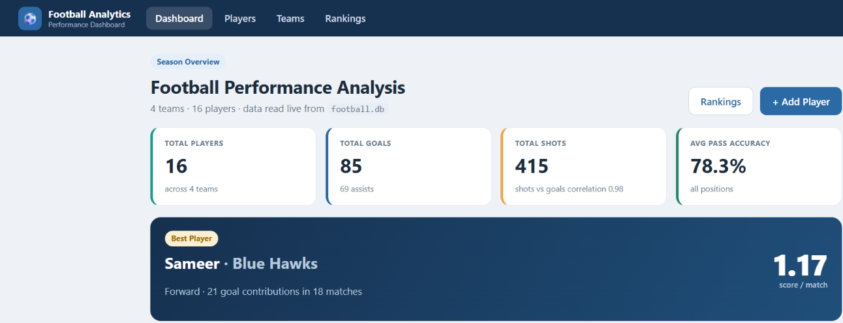
Screenshot 4.1: Dashboard page of the Football Analytics web application showing season totals and the best player.

4.2 Players Page
The Players page lists all 16 players with their team, position, matches, goals, assists, shots, shot accuracy, pass accuracy and score. Players can be searched by name, filtered by team and position, sorted, added, edited or deleted.
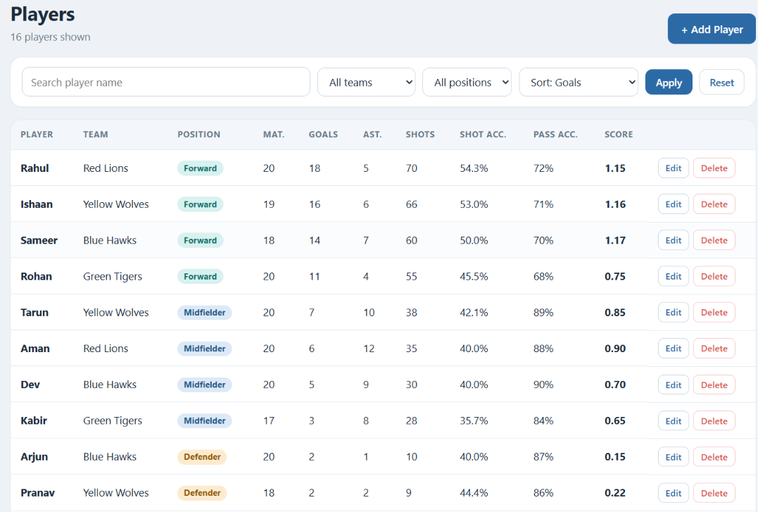
Screenshot 4.2: Players page listing all 16 players with search, filters and per-match score.

4.3 Teams Page
The Teams page groups the players of each team and shows the team totals of goals, assists and shots, the average pass accuracy, the shots on target and the squad of each team.
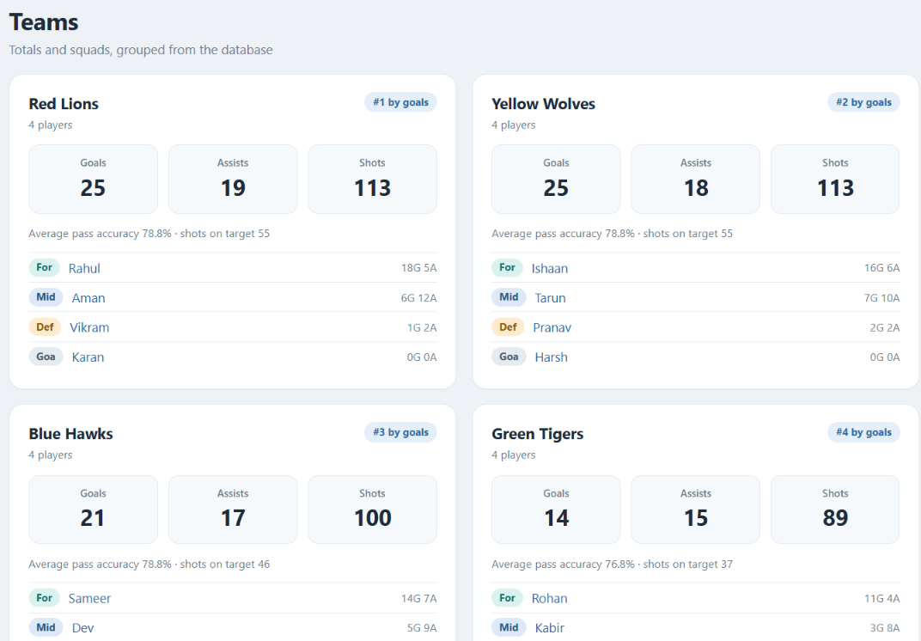
Screenshot 4.3: Teams page showing team totals (goals, assists, shots) and squads grouped from the database.

4.4 Best Player Ranking
The Rankings page ranks all players by the best player score, calculated as (goals + assists) divided by matches played, and shows the score of each player as a bar.
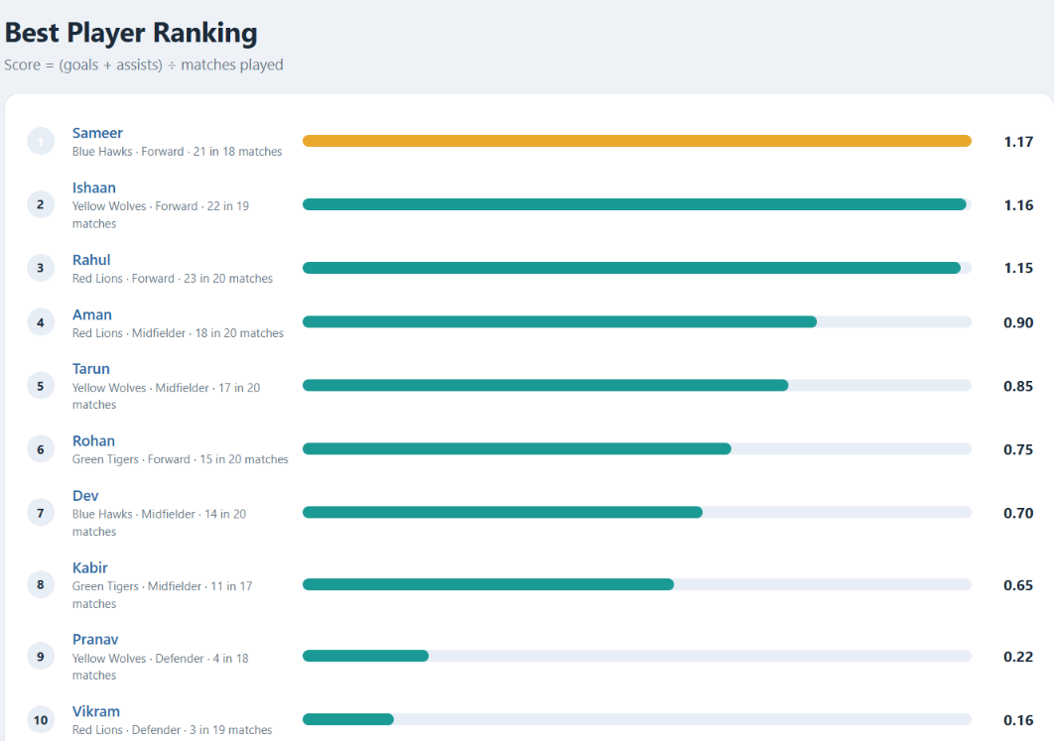
Screenshot 4.4: Rankings page showing the best player ranking by score = (goals + assists) / matches played.

4.5 Application Workflow
The program is executed in four stages: (1) load and inspect data, (2) create new columns, (3) perform analysis and print results, and (4) draw and save charts. The general workflow is shown below as numbered steps and as a flowchart (Figure 3).
- Start the script and import the libraries.  - Locate the script folder and read players.csv into a DataFrame.  - Inspect the data using head(), shape and isnull().sum().  - Add the four derived columns.  - Find the top scorers and rank the best players.  - Compute team totals, pass accuracy by position and the shots–goals correlation.  - Draw the dashboard, best-player chart and heat map.  - Save the charts as PNG images and print the results. | 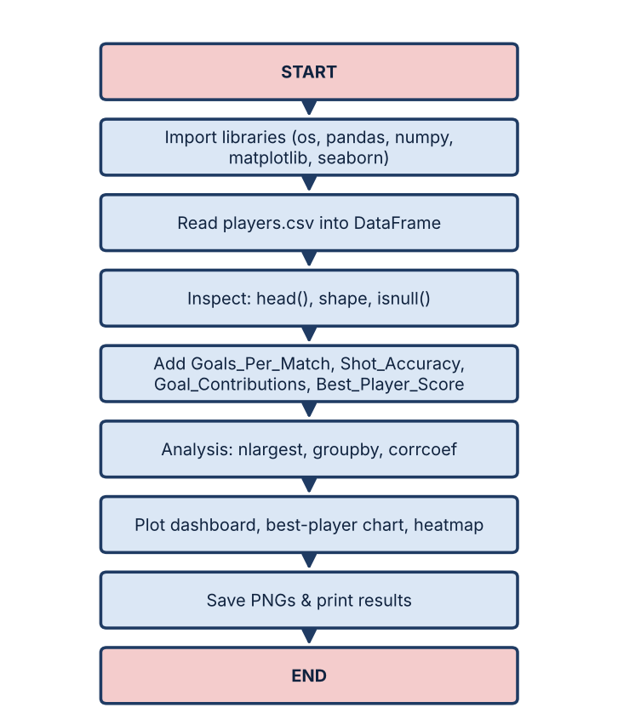  Fig3: Program Flowchart

5. IMPLEMENTATION, MODULES AND RESULTS
The program is a single script divided into numbered blocks, each responsible for a particular step of the analysis. This organisation improves readability and allows each step to be checked separately.

5.1 Main Application Module
The program football_analysis.py imports os, pandas, numpy, matplotlib.pyplot and seaborn. The script locates its own folder using os.path.dirname(os.path.abspath(__file__)), so players.csv and the saved images are always found in the same directory regardless of where the program is started from. The Seaborn theme is set to whitegrid and Pandas display options are widened so that all columns are printed.

5.2 Data Loading and Inspection
pd.read_csv loads the file into a DataFrame. The functions head(), shape and isnull().sum() confirm 16 rows × 11 columns and no missing values before any calculation is done.

5.3 Feature Derivation
np.round and np.where add the four new columns (Goals_Per_Match, Shot_Accuracy, Goal_Contributions and Best_Player_Score). For example, for Sameer (14 goals, 7 assists, 60 shots, 30 on target, 18 matches):
- Goals_Per_Match = 14 ÷ 18 = 0.78
- Shot_Accuracy = 30 ÷ 60 × 100 = 50.0
- Goal_Contributions = 14 + 7 = 21
- Best_Player_Score = 21 ÷ 18 = 1.17

5.4 Analysis Module
The analysis module uses nlargest to find the top three scorers, sort_values to rank players by Best_Player_Score, idxmax to select the best player, groupby to compute team totals and average pass accuracy by position, and np.corrcoef to measure the correlation between shots and goals.
Pseudocode: Analysis
ALGORITHM AnalysePlayers
BEGIN
READ players.csv INTO df
CHECK shape AND missing values
ADD Goals_Per_Match, Shot_Accuracy,
Goal_Contributions, Best_Player_Score
PRINT top 3 players by Goals
SORT df BY Best_Player_Score (descending)
PRINT top 5 AND SELECT best player
GROUP df BY Team -> SUM Goals, Assists, Shots
GROUP df BY Position -> MEAN Pass_Accuracy
COMPUTE correlation(Shots, Goals)
DRAW dashboard, best-player chart, heat map
SAVE charts AS PNG files
END

Algorithm 1: General analysis logic.

5.5 Visualisation Module
plt.subplots with Seaborn plots and savefig create the three image files: a four-panel dashboard (top six scorers, team goals/assists/shots, shots vs goals scatter plot and a pass-accuracy box plot), a bar chart of the eight best players by Best_Player_Score, and a correlation heat map of all numeric columns.

5.6 Dataset Used and Console Output
The program football_analysis.py was tested on players.csv (Table 5.1), which has a forward, a midfielder, a defender and a goalkeeper from each of four teams.
Table 5.1: Dataset used in the project (players.csv)
Player | Team | Position | Mat. | Min. | Goals | Ast. | Shots | SoT | Passes | Pass Acc.
Rahul | Red Lions | Forward | 20 | 1700 | 18 | 5 | 70 | 38 | 320 | 72
Aman | Red Lions | Midfielder | 20 | 1800 | 6 | 12 | 35 | 14 | 1100 | 88
Vikram | Red Lions | Defender | 19 | 1710 | 1 | 2 | 8 | 3 | 900 | 85
Karan | Red Lions | Goalkeeper | 20 | 1800 | 0 | 0 | 0 | 0 | 600 | 70
Sameer | Blue Hawks | Forward | 18 | 1500 | 14 | 7 | 60 | 30 | 280 | 70
Dev | Blue Hawks | Midfielder | 20 | 1750 | 5 | 9 | 30 | 12 | 1250 | 90
Arjun | Blue Hawks | Defender | 20 | 1800 | 2 | 1 | 10 | 4 | 950 | 87
Nikhil | Blue Hawks | Goalkeeper | 19 | 1710 | 0 | 0 | 0 | 0 | 550 | 68
Rohan | Green Tigers | Forward | 20 | 1650 | 11 | 4 | 55 | 25 | 260 | 68
Kabir | Green Tigers | Midfielder | 17 | 1400 | 3 | 8 | 28 | 10 | 980 | 84
Yash | Green Tigers | Defender | 20 | 1800 | 0 | 3 | 6 | 2 | 870 | 83
Manav | Green Tigers | Goalkeeper | 20 | 1800 | 0 | 0 | 0 | 0 | 640 | 72
Ishaan | Yellow Wolves | Forward | 19 | 1620 | 16 | 6 | 66 | 35 | 300 | 71
Tarun | Yellow Wolves | Midfielder | 20 | 1790 | 7 | 10 | 38 | 16 | 1180 | 89
Pranav | Yellow Wolves | Defender | 18 | 1620 | 2 | 2 | 9 | 4 | 920 | 86
Harsh | Yellow Wolves | Goalkeeper | 20 | 1800 | 0 | 0 | 0 | 0 | 580 | 69
Console output of the program:
Top 3 scorers:
Player Team Goals
0 Rahul Red Lions 18
12 Ishaan Yellow Wolves 16
4 Sameer Blue Hawks 14

Best Player ranking (Goal Contributions / Matches):
Player Team Position Goal_Contributions Matches Best_Player_Score
Sameer Blue Hawks Forward 21 18 1.17
Ishaan Yellow Wolves Forward 22 19 1.16
Rahul Red Lions Forward 23 20 1.15
Aman Red Lions Midfielder 18 20 0.90
Tarun Yellow Wolves Midfielder 17 20 0.85

BEST PLAYER: Sameer (Blue Hawks) with score 1.17

Team totals:
Goals Assists Shots
Team
Blue Hawks 21 17 100
Green Tigers 14 15 89
Red Lions 25 19 113
Yellow Wolves 25 18 113

Average pass accuracy by position:
Position
Defender 85.2
Forward 70.2
Goalkeeper 69.8
Midfielder 87.8
Name: Pass_Accuracy, dtype: float64

Correlation Shots vs Goals: 0.98

5.7 Interpretation of Results
- Top scorers: The dataset has 16 rows, 11 columns and no missing values. Rahul (Red Lions, 18 goals), Ishaan (Yellow Wolves, 16) and Sameer (Blue Hawks, 14) are the three top scorers.
- Best player: Sameer scores highest (21 contributions in 18 matches = 1.17), narrowly ahead of Ishaan (1.16) and Rahul (1.15). Rahul has more goals, but Sameer played fewer matches, which shows why a per-match measure is fairer.
- Team totals: Red Lions and Yellow Wolves tie on 25 goals and 113 shots; Green Tigers are weakest with 14 goals from 89 shots.
- Pass accuracy: Midfielders average 87.8% and defenders 85.2%, whereas forwards (70.2%) and goalkeepers (69.8%) are much lower.
- Shots vs goals: The correlation of 0.98 shows that players who shoot more also score more.

5.8 Dashboard, Best Player Chart and Heat Map
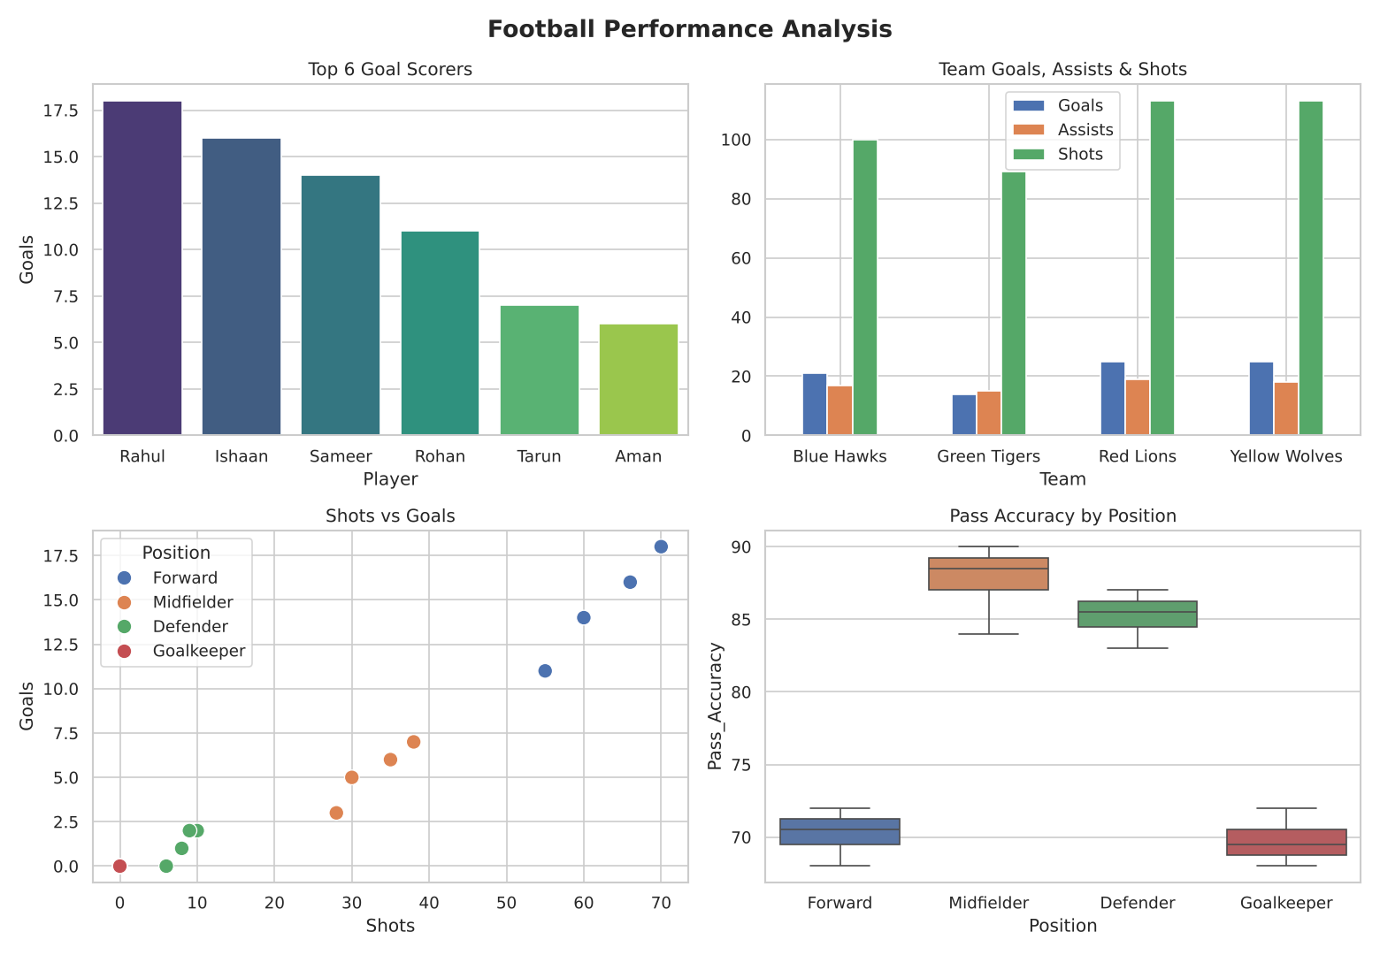
Figure 4: Football performance analysis dashboard.
Figure 4 supports the numerical findings: the top-left panel confirms the order of the top six scorers; the top-right panel shows that every team produced far more shots than goals; the scatter plot shows forwards forming a distinct upper-right cluster, followed by midfielders; and the box plot confirms the large gap in pass accuracy between midfielders/defenders and forwards/goalkeepers.
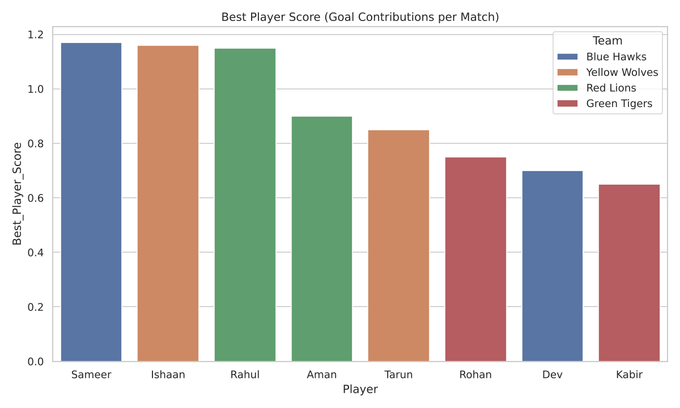
Figure 5: Best player score chart.
Figure 5 ranks the eight best players by Best_Player_Score. The top three are all forwards separated by only 0.02, followed by two midfielders (Aman and Tarun). Each team contributes at least one player to the chart.
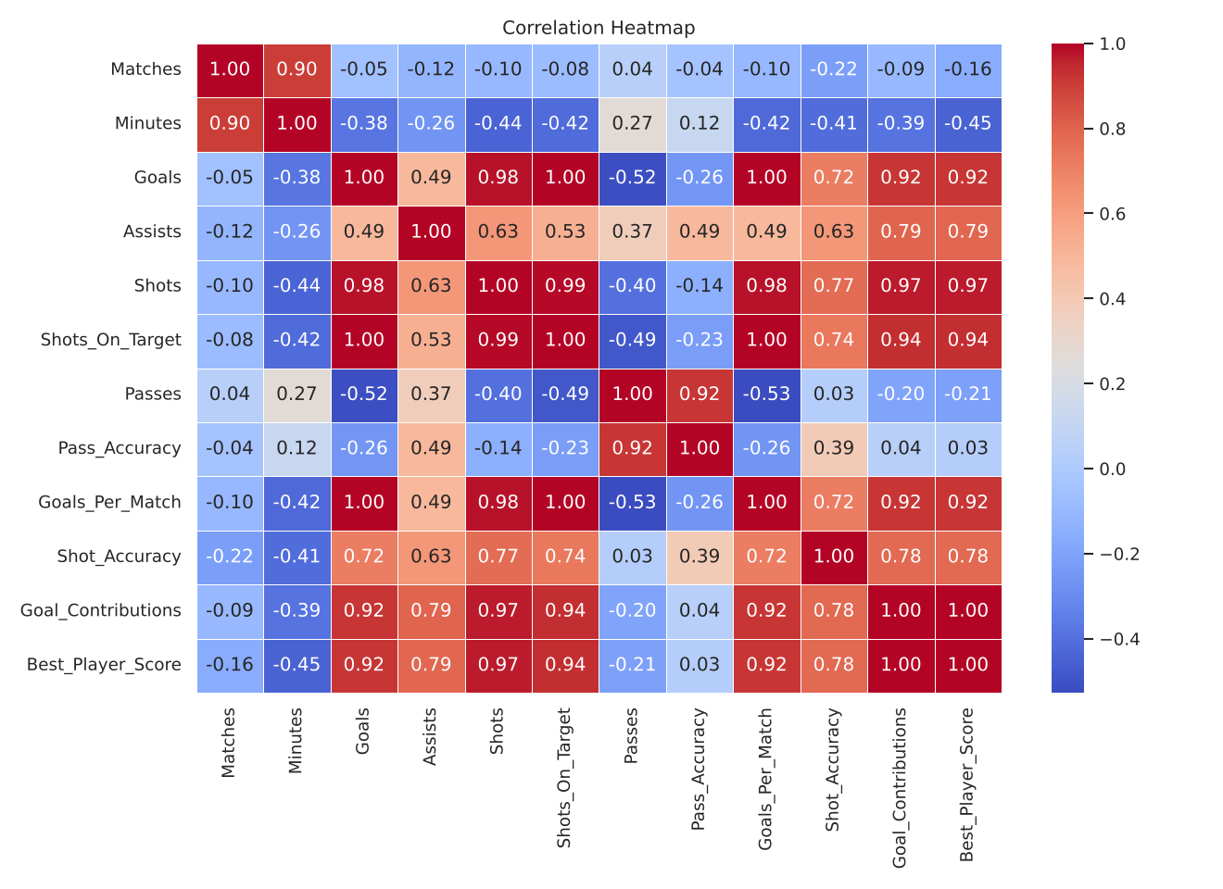
Figure 6: Correlation heat map.
The heat map shows very strong positive correlations between Goals, Shots, Shots_On_Target and Goal_Contributions (0.92 – 1.00), and a negative correlation between Passes and Goals (−0.52), reflecting that high-passing midfielders and defenders score less. Matches and Minutes are strongly related (0.90) as expected.

6. ADVANTAGES AND LIMITATIONS

6.1 Advantages
- Automation A single script replaces hours of manual calculation and can be re-run on new data in seconds.
- Fair Comparison Per-match measures give fairer rankings than raw counts.
- Transparency Every calculation is visible in the code and easy to explain to a non-technical reader.
- Visual Analytics The dashboard, ranking chart and heat map make the results easy to review.
- Reproducibility The script locates its own folder, so results can be regenerated anywhere.
- Free and Open Source All libraries used are free, unlike commercial analytics platforms.
- Offline Operation The program needs no internet connection or server.
- Academic Value The project demonstrates NumPy, Pandas, Matplotlib and Seaborn in a complete analytics workflow.

6.2 Limitations
- Small Dataset Only sixteen players are analysed, so conclusions are descriptive rather than statistically strong.
- Attacking Bias The Best Player Score uses only goals and assists, so defenders and goalkeepers are under-rated.
- Single Season The data covers one season and cannot show trends over time.
- Fixed CSV Input Data must be prepared manually in players.csv; there is no live data feed.
- No Prediction The project is descriptive and does not forecast future performance.
- No Interactive Interface Results are produced by running a script rather than through an interactive dashboard.

7. FUTURE SCOPE
The project provides a foundation for several useful improvements. Future development can focus on richer metrics, larger datasets, prediction and interactive presentation.

7.1 Richer Metrics
Tackles, interceptions, saves and clean sheets could be added so that defenders and goalkeepers can also be rated fairly.

7.2 Larger Datasets
Data from a full league or multiple seasons could be used to test whether the findings hold.

7.3 Predictive Modelling
scikit-learn models, for example regression, could be applied to predict goals from shots, passes and minutes.

7.4 Interactive Application
A Streamlit or Tkinter dashboard could be built where a coach can choose a team or player and see charts instantly.

7.5 Automation
Live data could be read from a web API or database instead of a fixed CSV file.

8. CONCLUSION
This project successfully used Python, NumPy, Pandas, Matplotlib and Seaborn to analyse the performance of sixteen football players. The dataset was clean, four useful derived measures were created, and the analysis identified Rahul as the top scorer, Sameer as the best player by contributions per match, Red Lions and Yellow Wolves as the most productive teams, and midfielders as the most accurate passers. The very high correlation (0.98) between shots and goals confirmed that shooting volume is closely linked to scoring in this dataset.
The project also showed that normalised measures give fairer rankings than raw counts, and that a short, readable script can replace hours of manual calculation. A limitation is that the best-player score ignores defensive and goalkeeping work, and that sixteen players are too few for strong statistical claims.
Overall, the project represents a practical application of Python programming and data visualisation to sports analytics and provides a clear foundation for more advanced work.

9. REFERENCES
- McKinney, W. (2022). Python for Data Analysis (3rd ed.). O’Reilly Media.
- Harris, C. R., Millman, K. J., et al. (2020). “Array programming with NumPy.” Nature, 585, 357–362.
- Hunter, J. D. (2007). “Matplotlib: A 2D graphics environment.” Computing in Science & Engineering, 9(3), 90–95.
- Waskom, M. L. (2021). “seaborn: statistical data visualization.” Journal of Open Source Software, 6(60), 3021.
- The pandas development team. pandas documentation. https://pandas.pydata.org/docs/
- Python Software Foundation. Python 3 documentation. https://docs.python.org/3/
- Anderson, C., & Sally, D. (2013). The Numbers Game: Why Everything You Know About Football Is Wrong. Penguin Books.
- Github : https://github.com/ashutoshdash8/Football-Performance-Analysis-.git
- http://127.0.0.1:5000
- GitHub Repository: https://github.com/ashutoshdash8/Football-Performance-Analysis-.git



